**Demonstrate how to work with POST requests**

Step-1:

First open postman

Step-2:

Then click on new button

Step-3:

Then click on HTTP

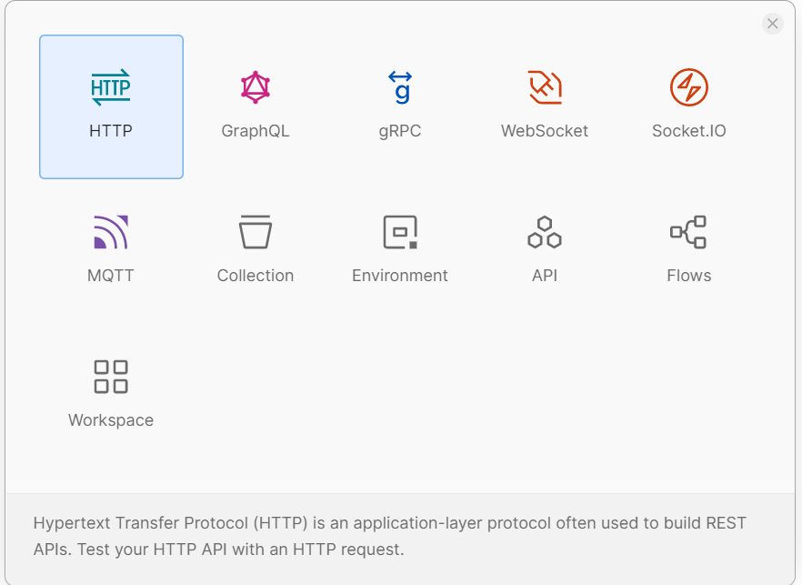

Step-4:

Then I select post method

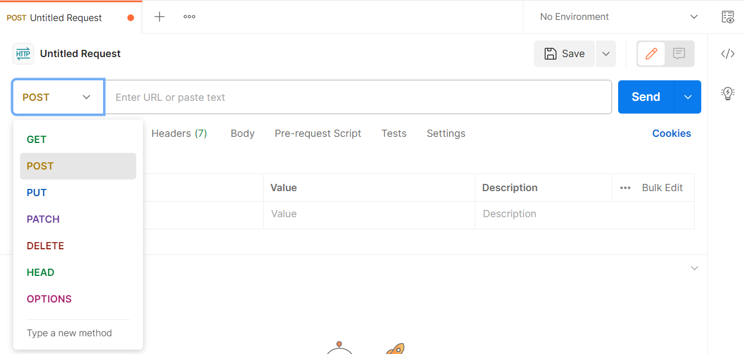

Step-5:

Then I pass json data in body section and click send button

